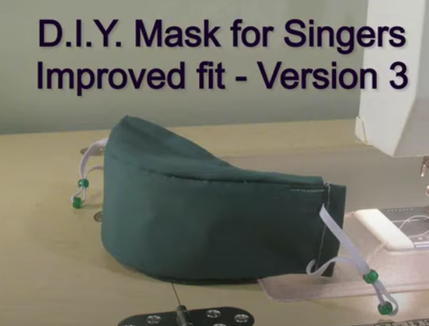

https://www.youtube.com/watch?v=8UNTP-m_K4E&ab_channel=SopranoJoan

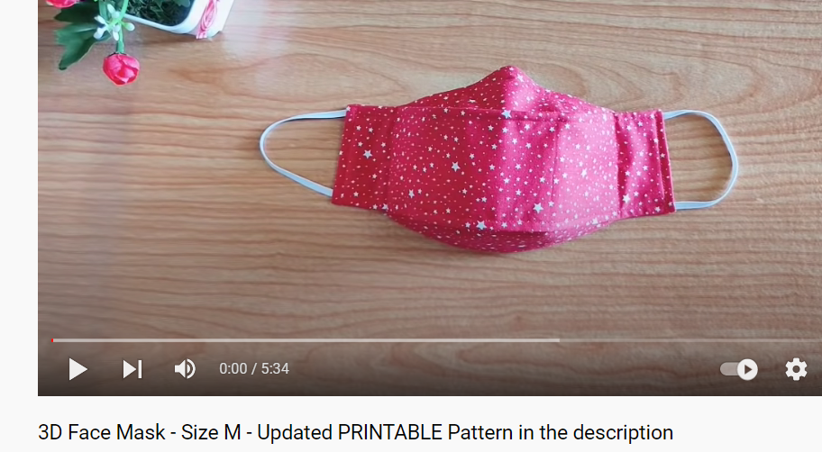
https://www.youtube.com/watch?v=dr2CWgg7Av0&ab_channel=JeloryCollection

